RICHMOND RECREATION
TIE DYE SNEAKERS

SUPPLIES:
-WHITE CANVAS SNEAKERS
-PERMANENT MARKERS
-RUBBING ALCOHOL FOR ADULTS TO HELP WITH

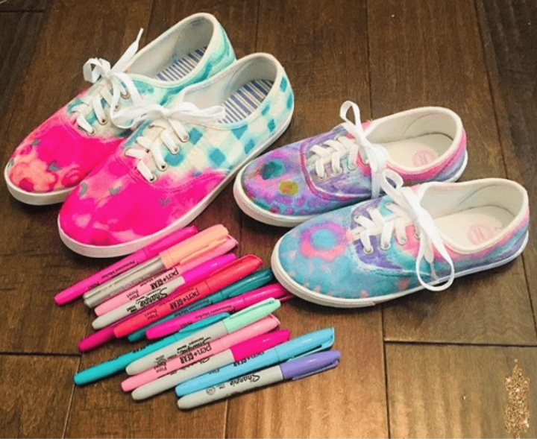

DIRECTIONS:

-COLOR SNEAKERS

-USE A COTTON BALL OR PIECE OF PAPER TOWEL WITH THE RUBBING ALCOHOL AND RUB OVER THE PERMANENT MARKER DESIGNS ON SNEAKERS TO CREATE THE TIE DYE AFFECT

-THEN LET THEM DRY

