RICHMOND RECREATION
SNOOPY
COLORING SHEETS
FOUND AT: WWW.PEANUTS.COM
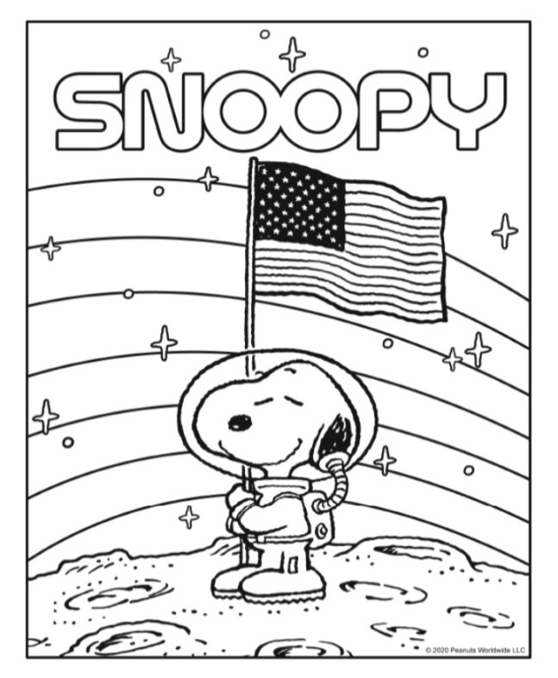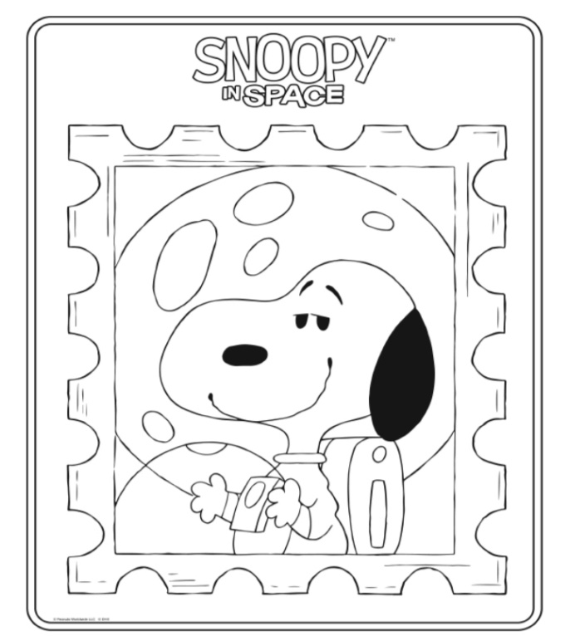
YOU CAN ALSO ACCESS SNOOPY IN SPACE
AT THIS WEBSITE AND IS FREE WITH APPLE TV
ALONG WITH IN HOME CLASSROOM IDEAS

