RICHMOND RECREATION
SNOOPY GOES TO MARS
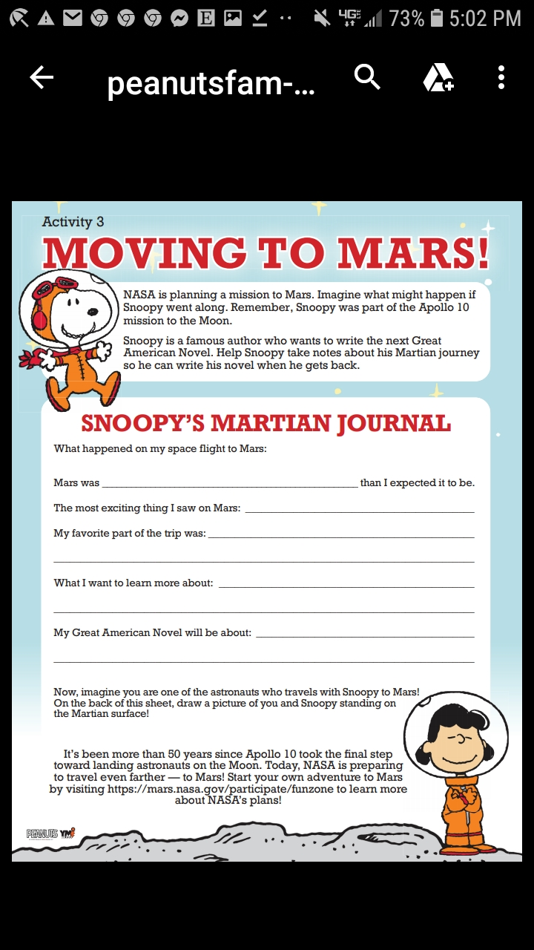
FOR MORE INFO. GO TO:
WWW.PEANUTS.COM
THEN CLICK ON IN HOME CLASSROOM IDEAS

