RICHMOND RECREATION
PLAY WITH SNOOPY
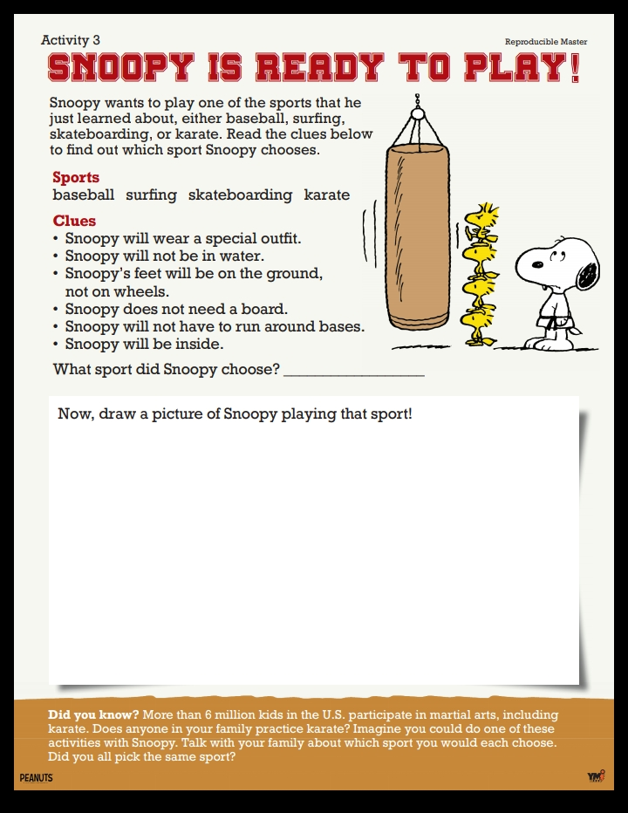
FOR MORE INFO. GO TO:
WWW.PEANUTS.COM

