RICHMOND RECREATION
SPRINGTIME WITH SNOOPY!
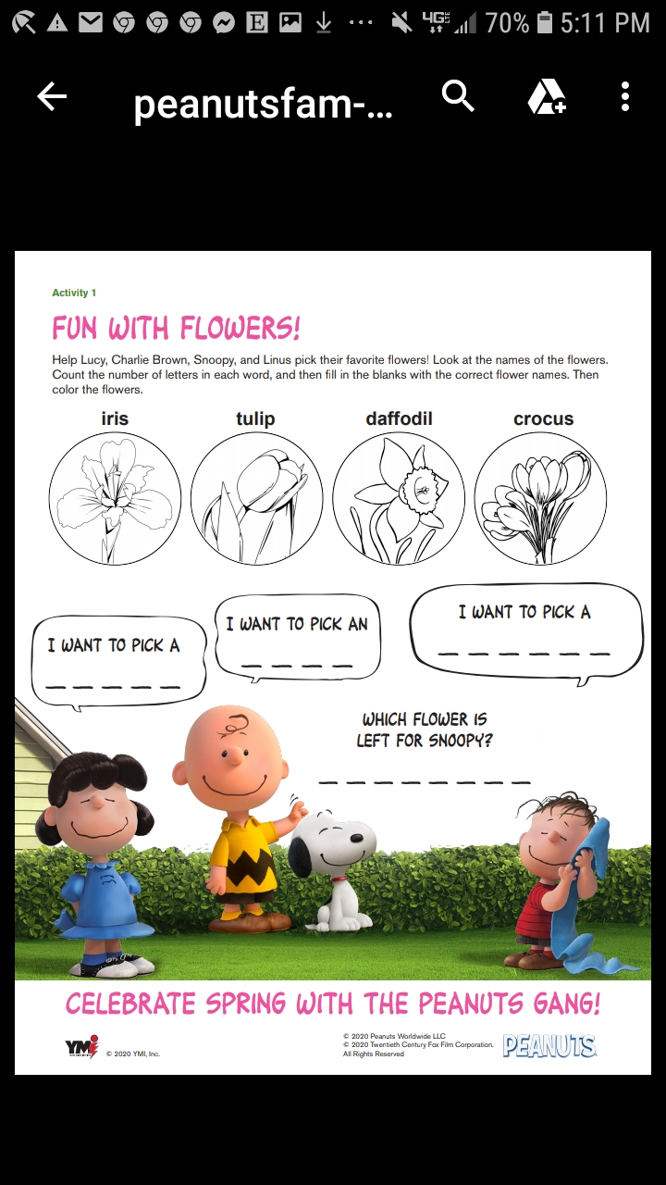
MORE ACTIVITIES WITH SNOOPY
CAN BE FOUND AT:
WWW.PEANUTS.COM

