RICHMOND RECREATION
SOAP BOAT RACES
SUPPLIES:
-BAR OF SOAP
-TOOTHPICK
-FABRIC
-SCISSORS
-GLUE
-HOSE WITH WATER
-GUTTER OR COULD USE A TARP OR GARBAGE BAG
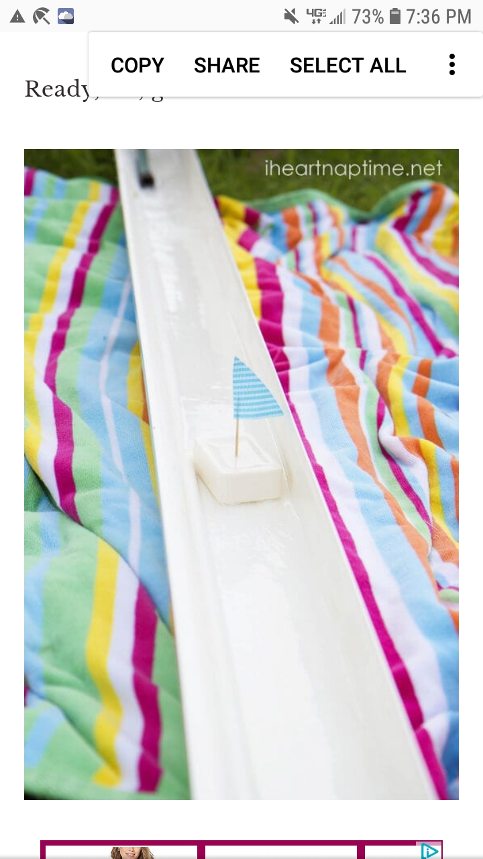
DETAILED INSTRUCTIONS
CAN BE FOUND AT:
WWW.ONECREATIVEMOMMY.COM

