RICHMOND RECREATION
POPSICLE STICK MONSTERS
SUPPLIES:
-PAPER
-SCISSORS
-PENCIL
-GLUE
-MARKERS
-POPSICLE STICKS
-PAINT
-PAINTBRUSH
-CONSTRUCTION PAPER
-GOOGLY EYES OPTIONAL

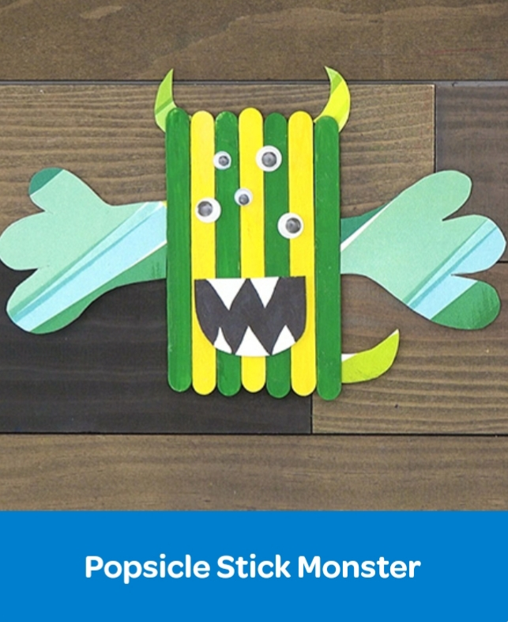

COMPLETE INSTRUCTIONS CAN BE FOUND AT:
WWW.CRAYOLA.COM
UNDER TRENDING CRAFTS

