RICHMOND RECREATION
CRAFT STICK UNICORN PUPPET

SUPPLIES:
-POPSICLE STICK
-CRAFT PAPER
-GLITTER FOAM
-RHINESTONE STICKERS
-BLACK MARKER
-PINK PENCIL
-BLUE PAINT & BRUSH

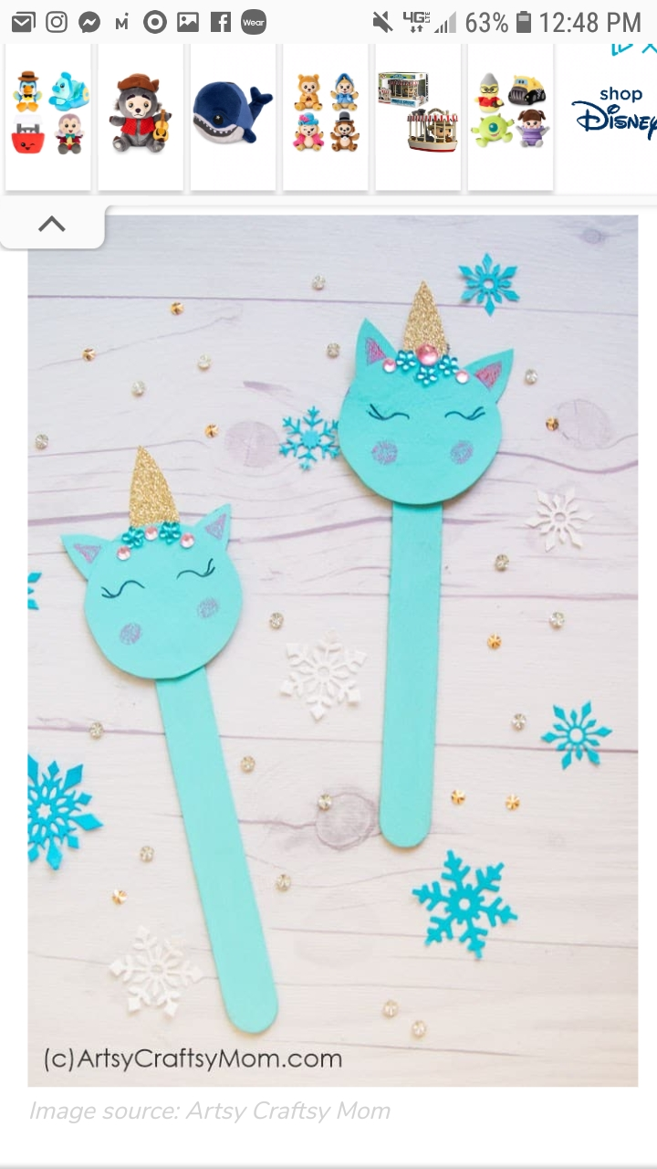

FOR COMPLETE INSTRUCTIONS GO TO:
WWW.ARTSYCRAFTSYMOM.COM

