RICHMOND RECREATION
SUPERHERO CUPCAKES
SUPPLIES:
-CAKE MIX
-FROSTING
-M&M’S

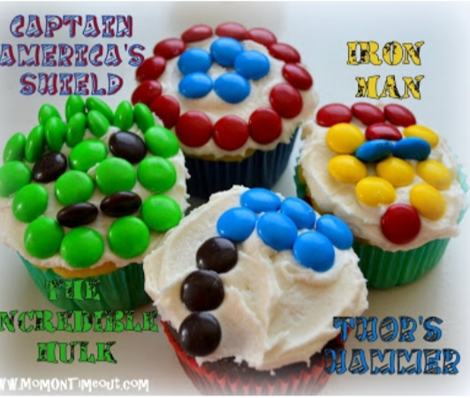

MAKE THE BATTER FOR CUPCAKES, BAKE, FROST & DECORATE WITH M&M’S IN YOUR FAVORITE SUPERHERO CHARACTER!
GREAT FOR FATHER’S DAY!

