RICHMOND RECREATION
SUPERHERO TERRARIUM
SUPPLIES:
-SAND
-JAR/GLASS CUP OR VOTIVE HOLDER
-PLASTIC SUPERHERE FIGURE OR DOLL FIGURE
-SHELLS
-SUCCULENTS

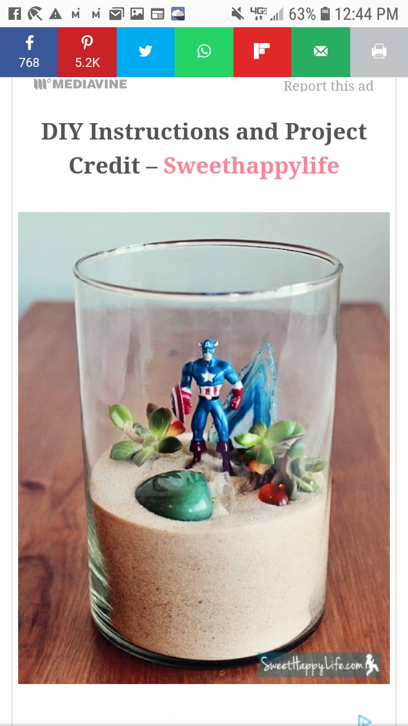

MAKES A GREAT FATHER’S DAY GIFT!

