RICHMOND RECREATION
TIC TAC TOE
SUPPLIES:
-3- 12X12 SQUARES OF PAPER OR FOAM (ANY 3 COLORS)
-PUFFY PAINT OR MARKERS
-PENCIL
-SCISSORS
-RULER
-PAPER OR FOAM FOR 5 X’s
-PAPER OR FOAM FOR 5 O’s
-PUFFY PAINT OR MARKERS TO DECORATE THE X’s & THE O’s

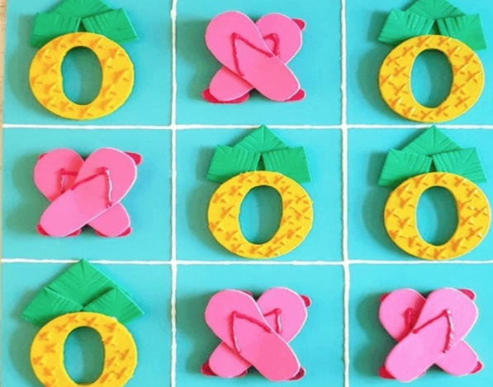
DIRECTIONS:
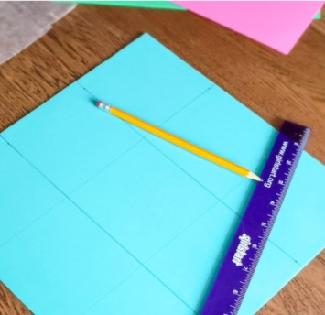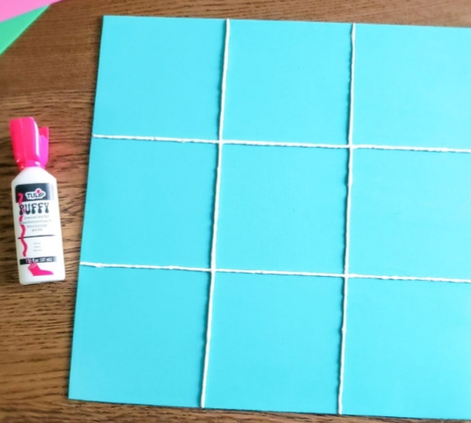
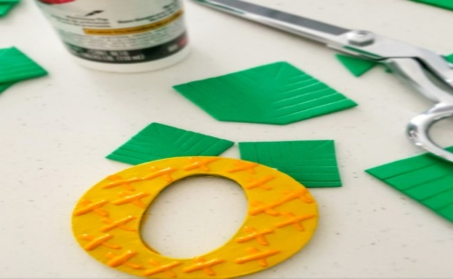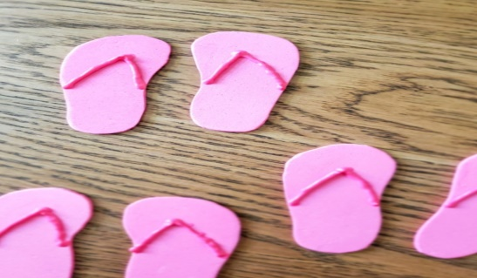
-GLUE THE FLIP FLOPS TOGETHER TO CREATE THE X’S AND ASSEMBLE THE O’S TO MAKE PINEAPPLES
HAVE FUN PLAYING!

