RICHMOND RECREATION
TIC TAC TOE FRISBEE

SUPPLIES:
-8 FRISBEES : 2 COLORS/4 OF EACH COLOR
-SHOWER CURTAIN OR TARP
-COLORED DUCT TAPE OR MASKING TAPE
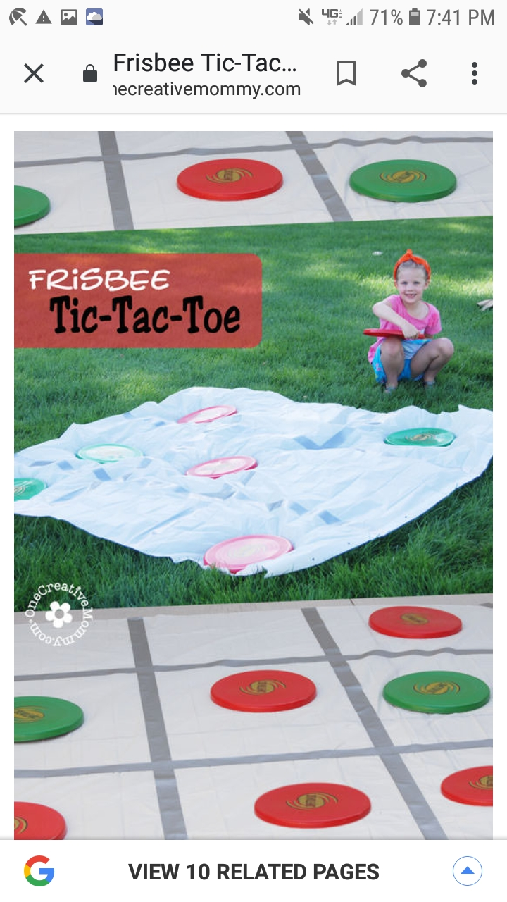

DETAILED INSTRUCTIONS
CAN BE FOUND AT:
WWW.ONECREATIVEMOMMY.COM

