RICHMOND RECREATION

TROLL BOOKMARK

SUPPLIES:
-COLORED CONSTRUCTION PAPER
-GLUE
-SHARPIE/MARKER
-SCISSORS
-TEMPLATE OF TROLL
-GOOGLY EYES OPTIONAL

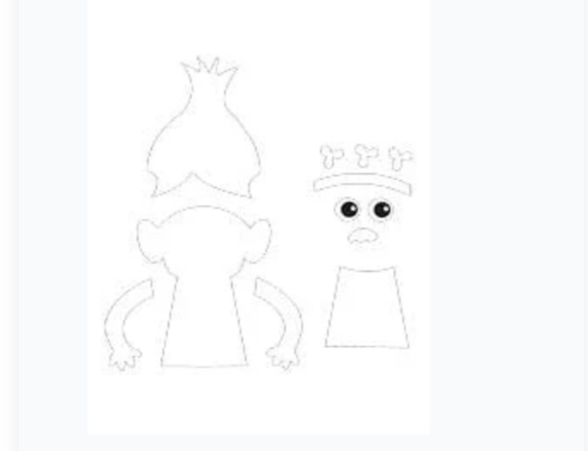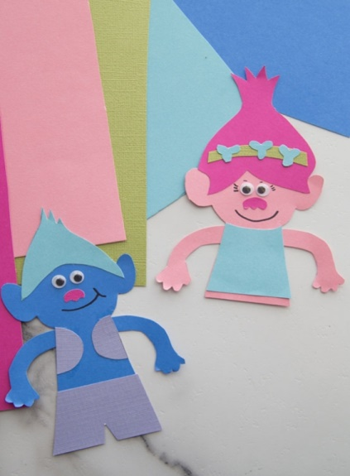
COMPLETE INSTRUCTIONS & TEMPLATE CAN BE FOUND ON:

WWW.THEBESTIDEASFORKIDS.COM

