RICHMOND RECREATION
WOODLAND PUMPKINS
SUPPLIES:
- GREY & TURQUOISE PAINT
-FOAM BRUSH
-GREY & ORANGE PAPER
-FELT GREY/ORANGE/TAN/BLACK/OFF WHITE
-BLACK SHARPIE MARKER
-SCISSORS
-HOT GLUE GUN (FOR ADULTS TO USE)
-PUMPKINS

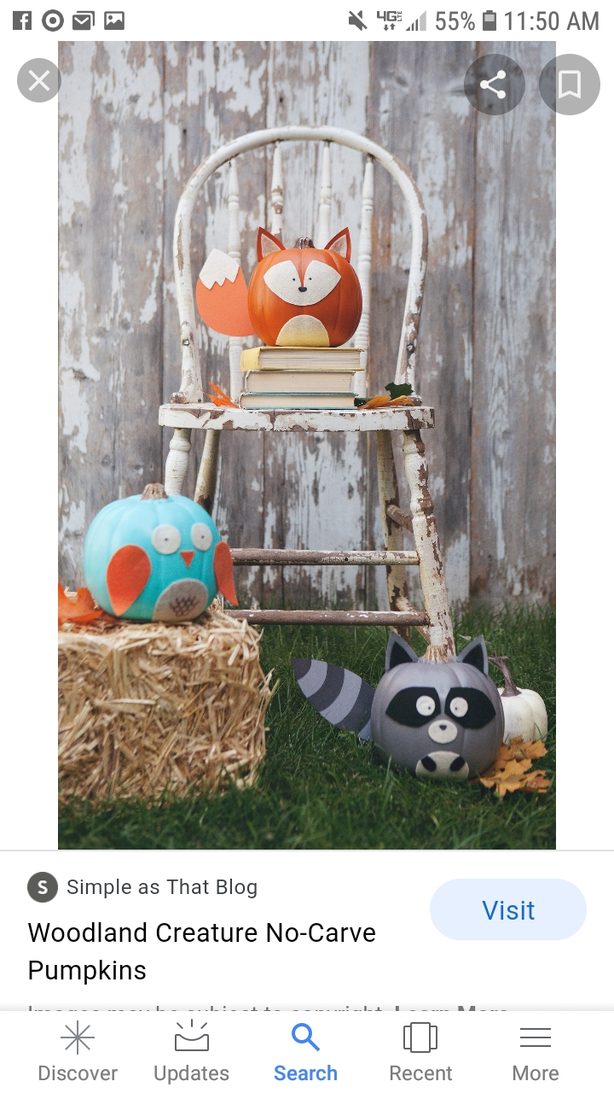

COMPLETE INSTRUCTIONS CAN BE FOUND AT:
WWW.SIMPLEASTHATBLOG.COM

